* **Set up your project:**
  + Create a new directory for your project and navigate into it using your terminal.
  + Initialize a new Node.js project:

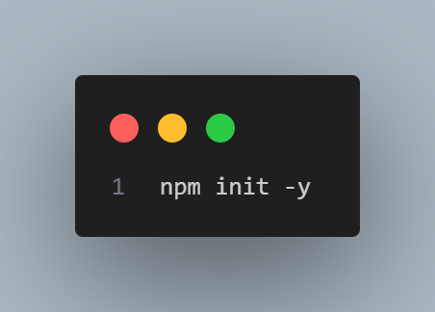

* **Install necessary packages:**
  + Install Express.js for building your web application and mysql2 (or mysql) for connecting to the MySQL database:
  + 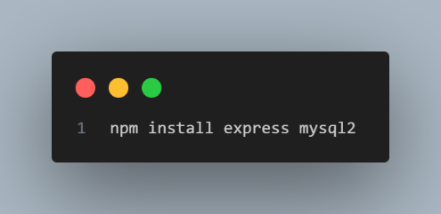
* 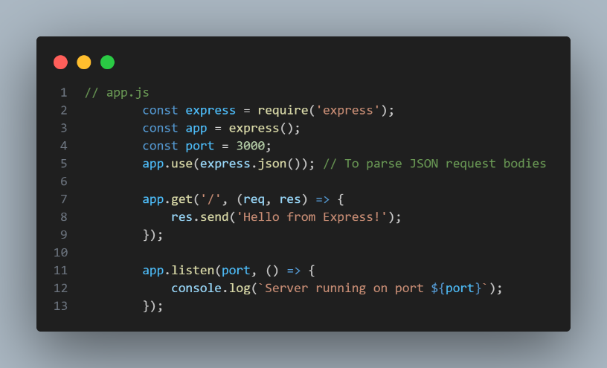**Create a basic Express application:**
  + Create a file (e.g., app.js or server.js) and set up a basic Express server:

* **Configure MySQL connection:**
  + Create a separate file (e.g., db.js) to handle your database connection logic. This promotes cleaner code and reusability.
  + Establish a connection pool for efficient database interaction:

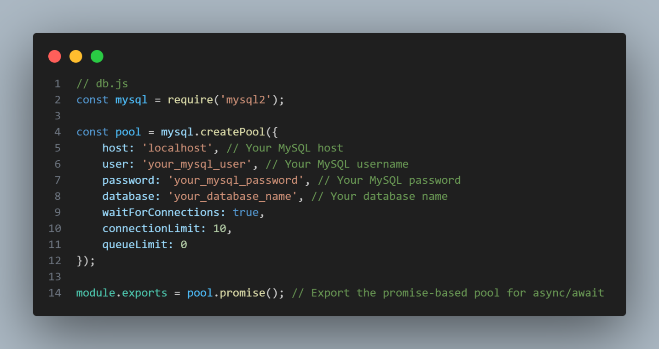

* **Important:** Replace 'localhost', 'your_mysql_user', 'your_mysql_password', and 'your_database_name' with your actual MySQL credentials and database name.
* **Integrate MySQL into your Express routes:**
  + In your app.js (or server.js), import the connection pool and use it in your routes to interact with the database.
  + Example of fetching data:

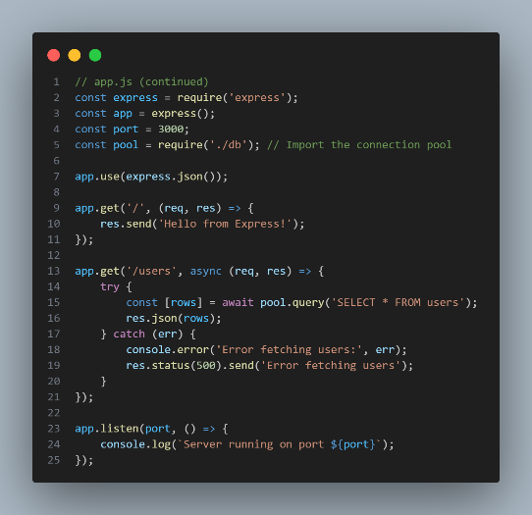

* **Run your application:**
  + Start your Express server from your terminal:
* You can now access your Express routes (e.g., http://localhost:3000/users) to interact with your MySQL database.

Add Record

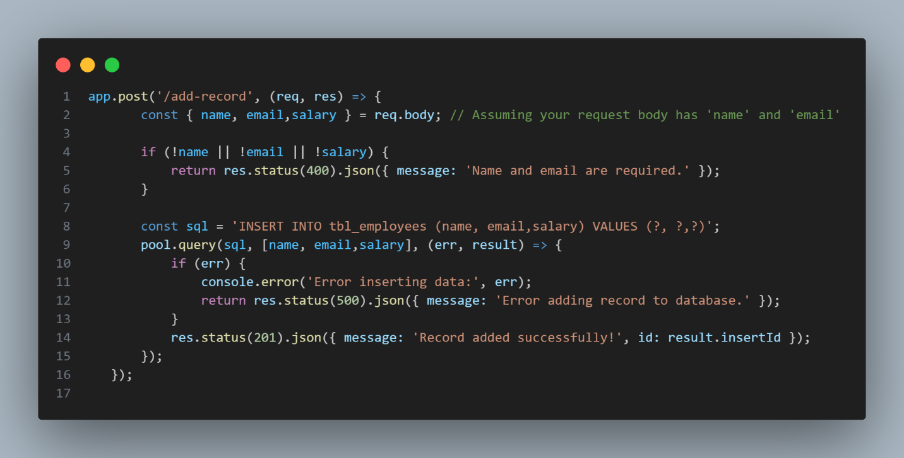

Get Single Record

